FAQs for COP26 SAF supply in the UK

What is sustainable aviation fuel (SAF)?

Sustainable aviation fuel (SAF) is an alternative to fossil-based conventional jet fuel that has significantly lower life-cycle carbon emissions. SAF is made from renewable sustainable sources such as used cooking oil, agricultural residues or household wastes that would have gone to landfill. When the lifecycle emissions of SAF are calculated, they result in around 80-95% less CO2 lifecycle emissions compared to conventional jet fuel. Currently, when blended up to 50% with conventional jet fuel the SAF blend is designed to meet the same strict quality standards as conventional jet fuel so that it can simply be dropped into existing aircraft and fuel infrastructure.

What are lifecycle greenhouse gas savings?

Lifecycle Greenhouse Gas (GHG) savings represent the difference in GHG emissions between using SAF as opposed to the conventional fuel they replace. We measure all the emissions associated with the extraction, processing, distribution and use of fossil fuels and then compare that with the equivalent production system for waste derived SAF. Because the waste oils and fats we are using to produce the SAF are derived from biomass - which takes CO2 from the atmosphere via photosynthesis, SAF can deliver GHG savings above 80% in many cases.

Lifecycle of fossil kerosene:
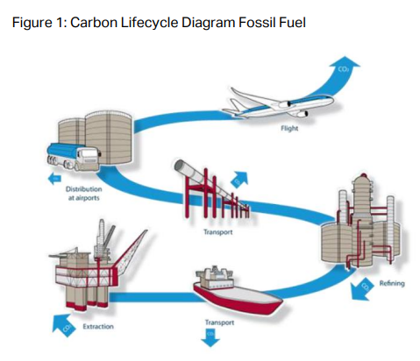

Lifecycle of biomass and waste based fuels:
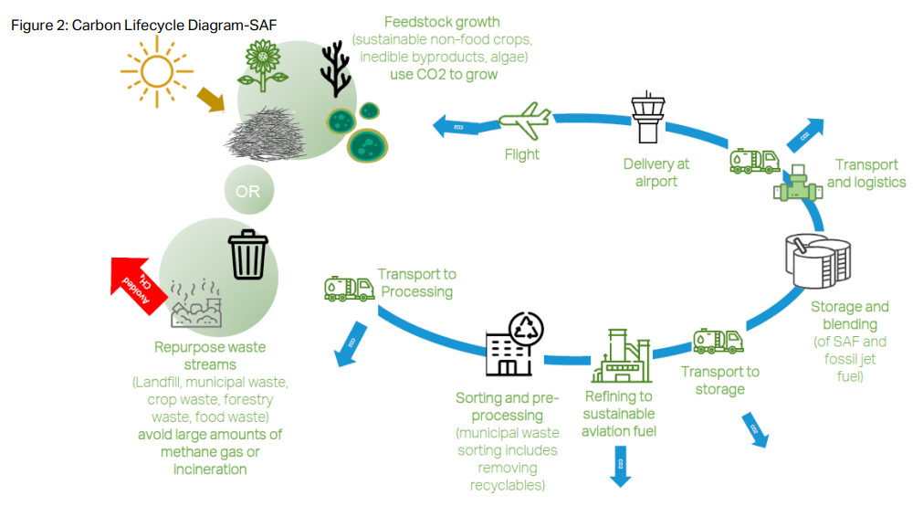
(Images provided by ATAG/IATA)

Can SAF cause deforestation?

Some biofuels have been linked to deforestation – caused when additional land is converted from forests or other important high carbon stock land in order to produce bioenergy. Producing SAF using waste materials prevents any additional pressure on land so the fuels being manufactured for COP26 do not cause deforestation. Sustainability certification of the fuel looks at the origin of the waste to ensure that the feedstocks used are genuine waste products.

Doesn’t SAF still produce CO2 when it is consumed?

Yes, it does. However, when we consume fossil fuels, we release carbon molecules that have been trapped underground for over 300 million years – significantly adding to the total carbon dioxide in the atmosphere. Conversely, when we use carbon from biogenic materials these carbon atoms have only just been captured from the atmosphere through the natural process of photosynthesis. Then as we consume sustainable fuels, we return these carbon molecules back to the environment. You can find more details on life cycle carbon saving in question 2.

- Will the SAF all be loaded on to my flight?

The fuel suppliers have different ways of suppling SAF to airports for COP26; please discuss the options directly with your fuel supplier. For operational reasons, in most airports, there isn’t dedicated SAF infrastructure to supply the SAF blend to specific aircraft. As such, the SAF blend will use the existing fuel infrastructure and mix with conventional fuel before it reaches an aircraft. Therefore, all aircraft refuelling at the airport may receive SAF molecules, however, only the aircraft purchasing the SAF can claim the carbon savings. One supplier has segregated storage and refuelling facilities available at Prestwick airport (PIK) during the COP26 period. As such, SAF will go directly into the flights for which it’s been purchased.

- What are the sources of SAF that I would be purchasing?

The supplies for COP26 are based on used cooking oil and meet the UK Government’s strict sustainability criteria. As the SAF is based on wastes and residues, this ensures it delivers high CO2 reductions, typically 80-95% lower than conventional jet fuel it replaces.

What sustainability criteria does the SAF meet?

We ensure that the SAF supplied meets the UK Government’s Renewable Transport Fuel Obligation rules and has been through a sustainability assessment using recognised sustainability certification systems. These assessment systems are independently verified and ensure that the fuel genuinely delivers carbon savings. The certification process also ensures that the whole life cycle greenhouse gas emissions are accurately calculated and that systems are in place to minimise the impact of producing the fuel on the land and the environment.

What acknowledgement will I get once I have supported SAF?

The fuel supplier will provide evidence to outline the purchase that you have made and to confirm that the emission reductions have been achieved.

Can I use SAF on flights into and out of the UK?

SAF is not widely available yet – but many projects are now under development or construction. There are some supplies of SAF available at various locations around the world and these are listed on the supplier directory which you can access here. So that the right volumes of SAF can be made available at the right event airports in Scotland, please get in touch with fuel suppliers as early as possible to discuss your requirements.

